Consuming a Web Service (Creation of Client Proxy).

Concept:
- Every Web service is generated with a Web Service Definition Language (WSDL).
- We will use the WSDL to create a Client Proxy.

Example: Suppose we have two systems L5D & LSD .We have created a web service in L5D & We want to consume that Web service in LSD.For this we have to create a Client Proxy In LSD with the help of WSDL that is generated with the web service which is made in L5D.

Steps for Creating a Client Proxy:
1. Go to T-code Se80.
- Go to Edit Object ->Enterprise Services->Client Proxy (Radio Button).

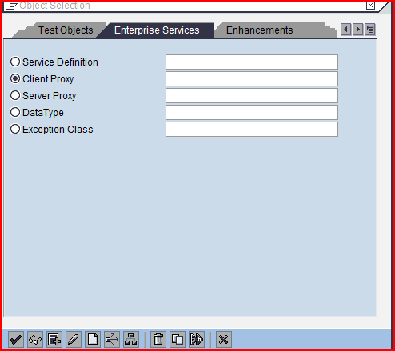

Click on the create button.
- The following screen appears.

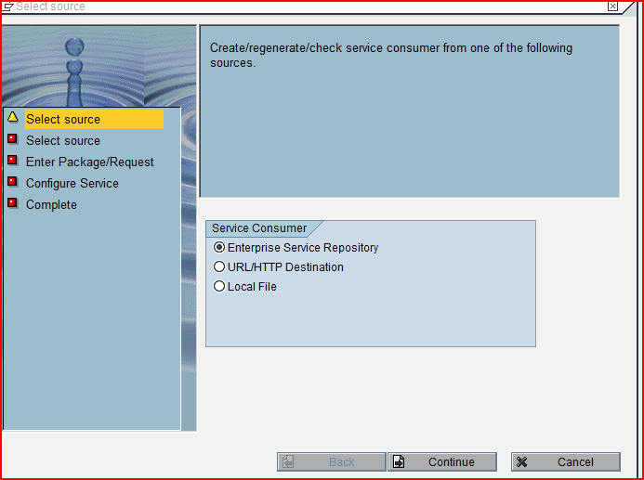

Select the radio button URL/HTTP Destination and click on the continue button.

4. The following screen appears.

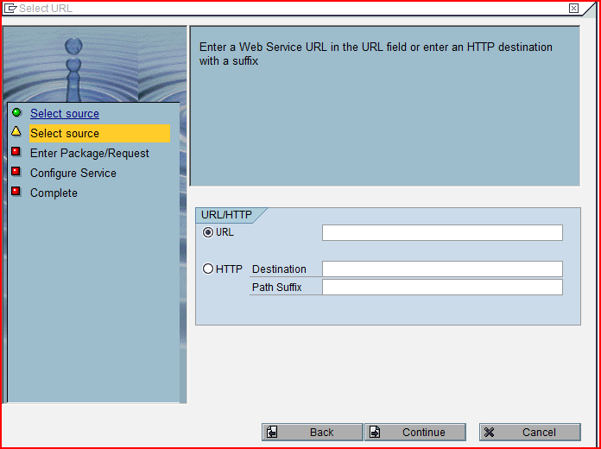

In the URL provide the Web service definition language (WSDL) of the web service. (How to Get WSDL Refer Point 10 in the first document (Creation of Web Service)).

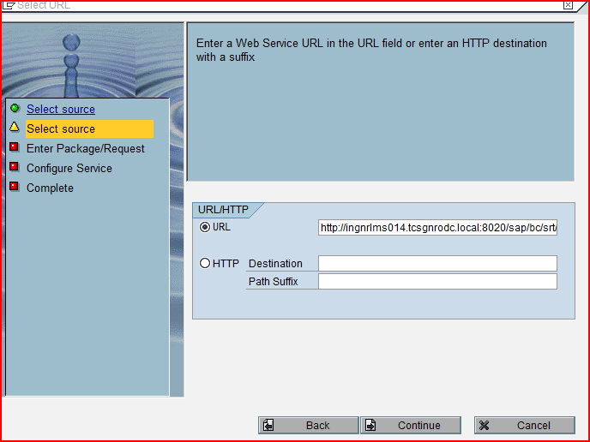

Click on the continue button.

- The following screen appears.

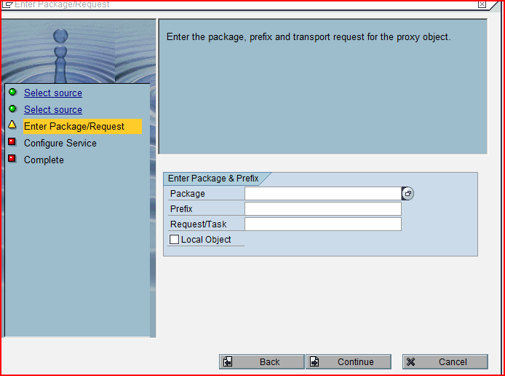

Provide the prefix and stored it in a package or in a local request.

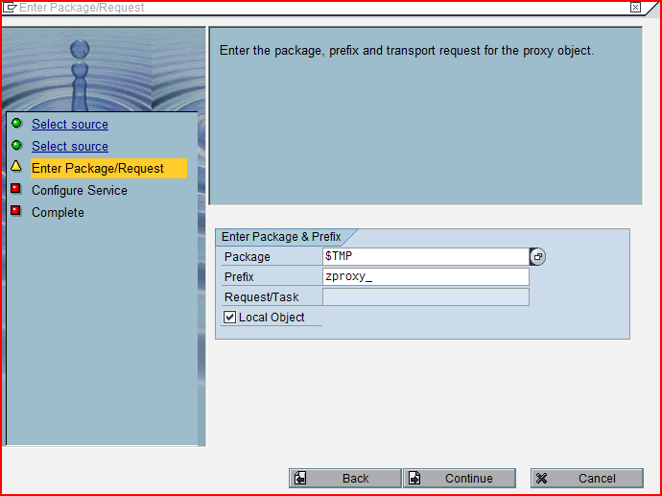

Click on the continue button.

- The following screen appears.

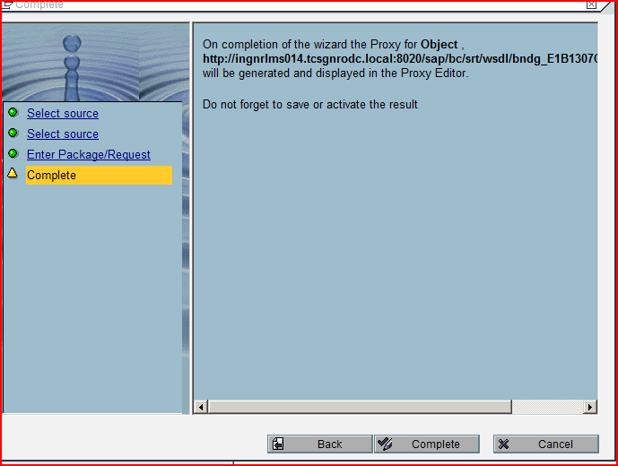

Click on the complete button.

- After clicking on the complete button the following pop-up appears asking for filling the user id and password.

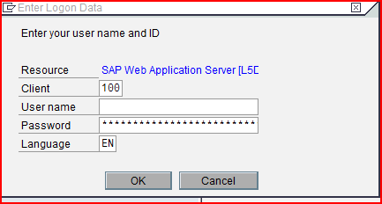

This user id and password is of that system in which web service exists. (Permission to use the web service of another system).

Provide the user name and the password and Click on the OK button.

- The following screen appears and the proxy is created.

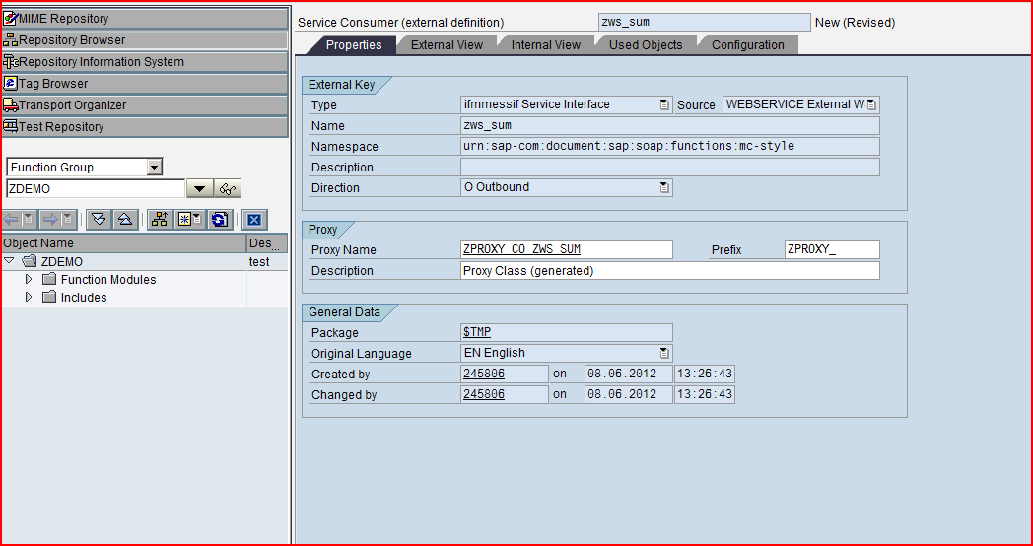

Save and activate the proxy. This Proxy is nothing but a class which exists in SE24.
The name of the proxy is always like this: Consumer Proxy Prefix + CO + Name of the Web Service.

- Go to T-Code ‘SOAMANAGER’ and give the name of the Client Proxy which you have created. (In the search by drop down select Consumer proxy).

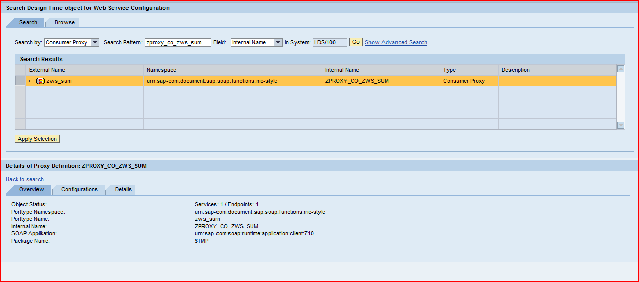

- Apply Selection and go to configuration tab to create the Logical Port.

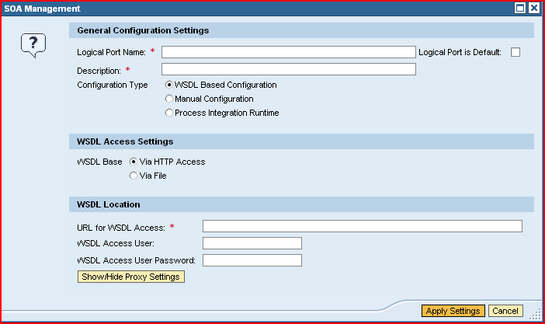

Provide the logical port name and its description.
URL for WSDL Access: WSDL of the web service
Provide the user name and the Password of the system in which web service exists and click on apply settings.

- The Following Screen Appears.

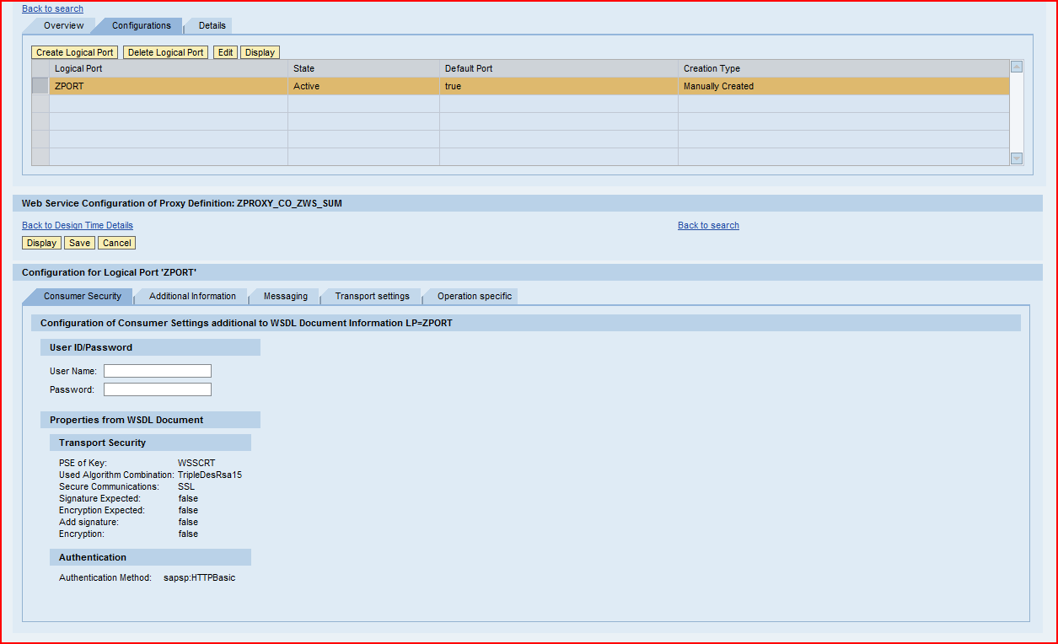

Click on save button. The binding for the web service activated.

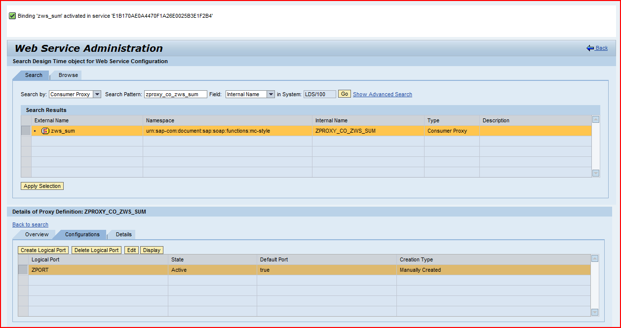

- Now Create an Executable program in this create an object for the Client Proxy.

DATA:lo_object TYPE REF TO ZCP_LDSCO_ZWS_FM_L5D.
DATA:ls_input TYPE ZCP_LDSZFM_L5D.
DATA:ls_output TYPE ZCP_LDSZFM_L5D_RESPONSE.
CREATE OBJECT lo_object
EXPORTING logical_port_name = 'ZPORT_LDS'.
TRY.
CALL METHOD lo_object->zfm_l5d
EXPORTING
input = ls_input
IMPORTING
output = ls_output
.
CATCH cx_ai_system_fault .
CATCH cx_ai_application_fault .
ENDTRY.

Lo_OBJECT = Client Proxy Object.
LS_INPUT = Input Parameter of the RFC FM.
LS_OUTPUT = Output Parameter of the RFC FM.

This client Proxy calls the RFC FM.The Output of the Method can be used for further processing.

